**Primitive Data types in Java**

## NAME: S. Ajay Kumar

## REGISTER NUMBER: 2024503701

**1.1 CODE:**

import java.util.Scanner;  
  
public class Calculator {  
 public static void main(String[] args) {  
 System.*out*.println("Name : S. Ajay Kumar");  
 System.*out*.println("Roll No : 2024503701");  
  
 Scanner sc = new Scanner(System.*in*);  
  
 System.*out*.print("Enter first number: ");  
 double num1 = sc.nextDouble();  
  
 System.*out*.print("Enter second number: ");  
 double num2 = sc.nextDouble();  
  
 System.*out*.print("Enter operator (+, -, *, /): ");  
 char operator = sc.next().charAt(0);  
  
 double result;  
  
 if (operator == '+') {  
 result = num1 + num2;  
 System.*out*.println("Result: " + result);  
 } else if (operator == '-') {  
 result = num1 - num2;  
 System.*out*.println("Result: " + result);  
 } else if (operator == '*') {  
 result = num1 * num2;  
 System.*out*.println("Result: " + result);  
 } else if (operator == '/') {  
 if (num2 != 0) {  
 result = num1 / num2;  
 System.*out*.println("Result: " + result);  
 } else {  
 System.*out*.println("Error: Division by zero is not allowed.");  
 }  
 } else {  
 System.*out*.println("Invalid operator.");  
 }  
  
 sc.close();  
 }  
}

**OUTPUT:**

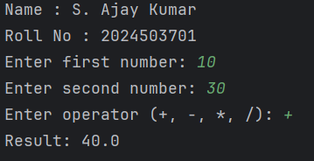

**1.2 CODE:**

import java.util.Scanner;  
  
public class TeamStatus {  
 public static void main(String[] args) {  
 System.*out*.println("Name : S. Ajay Kumar");  
 System.*out*.println("Roll No : 2024503701");  
 Scanner sc = new Scanner(System.*in*);  
  
 System.*out*.print("Enter team runs: ");  
 int runs = sc.nextInt();  
  
 System.*out*.print("Enter number of fouls: ");  
 byte fouls = sc.nextByte();  
  
 boolean winStatus = (runs >= 50 && fouls <= 5);  
  
 System.*out*.println("\n--- Team Performance ---");  
 System.*out*.println("Runs: " + runs);  
 System.*out*.println("Fouls: " + fouls);  
 System.*out*.println("Win Status: " + winStatus);  
  
 sc.close();  
 }  
}

**OUTPUT:**

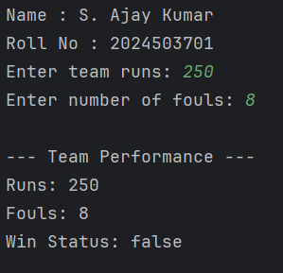

**1.3 CODE:**

import java.util.Scanner;  
  
public class BMICheck {  
 public static void main(String[] args) {  
 System.*out*.println("Name : S. Ajay Kumar");  
 System.*out*.println("Roll No : 2024503701");  
 Scanner sc = new Scanner(System.*in*);  
  
 System.*out*.print("Enter weight in kilograms: ");  
 double weight = sc.nextDouble();  
  
 System.*out*.print("Enter height in meters: ");  
 double height = sc.nextDouble();  
  
 double bmi = weight / (height * height);  
  
 boolean isNormal = (bmi >= 18.5 && bmi < 25);  
  
 System.*out*.println("\n--- BMI Report ---");  
 System.*out*.println("BMI: " + bmi);  
 System.*out*.println("Is BMI Normal? " + isNormal);  
  
 sc.close();  
 }  
}

**OUTPUT:**

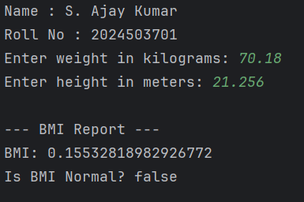

**1.4 CODE:**

import java.util.Scanner;  
  
public class TemperatureCheck {  
 public static void main(String[] args) {  
 System.*out*.println("Name : S. Ajay Kumar");  
 System.*out*.println("Roll No : 2024503701");  
 Scanner sc = new Scanner(System.*in*);  
  
 System.*out*.print("Enter temperature in Celsius: ");  
 double celsius = sc.nextDouble();  
  
 double fahrenheit = (celsius * 9 / 5) + 32;  
  
 boolean isHot = (fahrenheit > 100);  
  
 System.*out*.println("\n--- Temperature Report ---");  
 System.*out*.printf("Temperature: %.1f°C (%.1f°F)\n", celsius, fahrenheit);  
 System.*out*.println("Is it hot? " + isHot);  
  
 sc.close();  
 }  
}

**OUTPUT:**

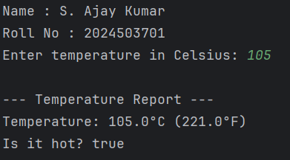

**1.5 CODE:**

import java.util.Scanner;  
  
public class StudentResult {  
 public static void main(String[] args) {  
 System.*out*.println("Name : S. Ajay Kumar");  
 System.*out*.println("Roll No : 2024503701");  
 Scanner sc = new Scanner(System.*in*);  
  
 System.*out*.print("Enter marks for Subject 1: ");  
 float mark1 = sc.nextFloat();  
  
 System.*out*.print("Enter marks for Subject 2: ");  
 float mark2 = sc.nextFloat();  
  
 System.*out*.print("Enter marks for Subject 3: ");  
 float mark3 = sc.nextFloat();  
  
 float total = mark1 + mark2 + mark3;  
 float average = total / 3;  
  
 // Check if any subject is less than 50  
 boolean passStatus = (mark1 >= 50 && mark2 >= 50 && mark3 >= 50);  
 char grade;  
  
 if (!passStatus) {  
 grade = 'U'; // U for fail  
 } else if (average >= 90) {  
 grade = 'S';  
 } else if (average >= 80) {  
 grade = 'A';  
 } else if (average >= 70) {  
 grade = 'B';  
 } else if (average >= 60) {  
 grade = 'C';  
 } else if (average >= 50) {  
 grade = 'D';  
 } else {  
 grade = 'U';  
 }  
  
 System.*out*.println("\n--- Student Result ---");  
 System.*out*.println("Total Marks: " + total);  
 System.*out*.println("Average: " + average);  
 System.*out*.println("Grade: " + grade);  
 System.*out*.println("Pass Status: " + passStatus);  
  
 sc.close();  
 }  
}

**OUTPUT:**

